If you are experience this crash trying to load the models, and you're not sure why, it's probably an Xcode 9 **bug**.

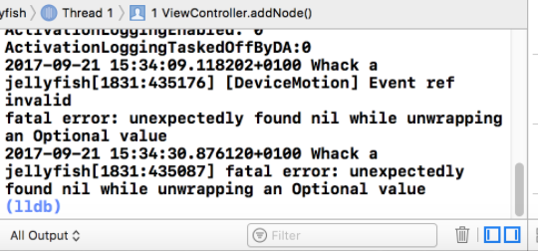

 This crash occurs when Xcode can't find the Scene file that you're referencing. The problem is, every time the app is run, the scene file is moved out of the SCNAssets folder.

There are two ways to fix it.

**FIRST METHOD**

You will have to go into the **finder, find** your project,  and **physically drag,**your scene scene files back into your **scnassets folder.**

**SECOND METHOD**

2) Due to an Xcode update, you cannot drag the Ikea models like how I did in the video. If you want to avoid crashes, you'll have to follow these steps.

Go to File - New - File

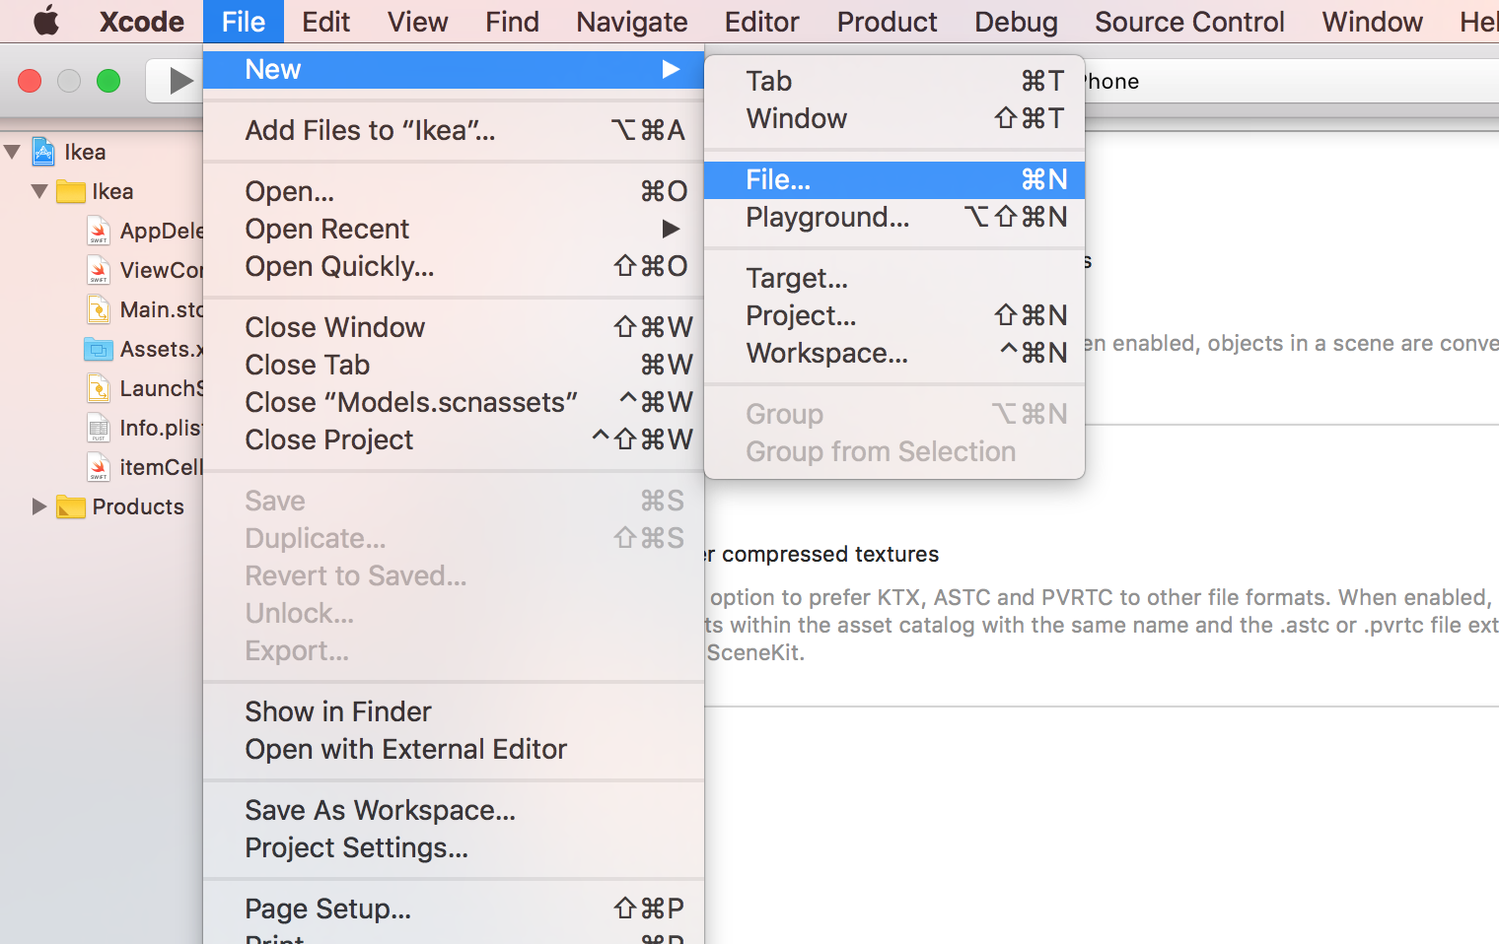

Make sure it's an Asset Catalog, then click Next

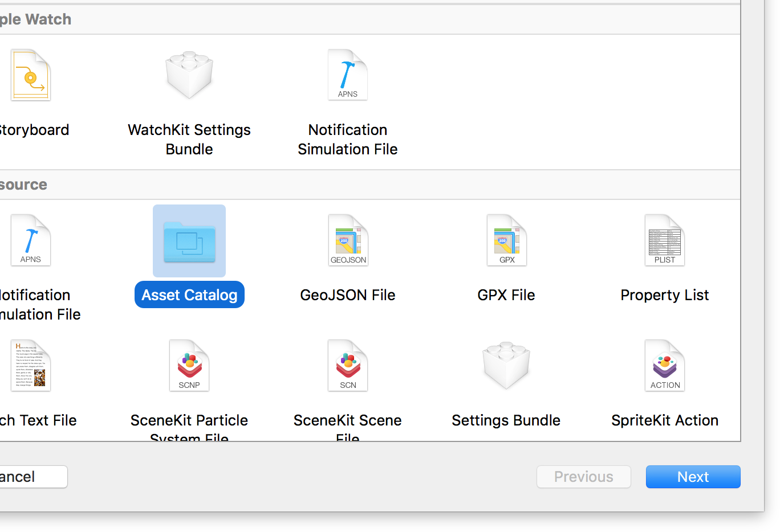

Call it whatever you want, Press Create

It should pop up in your project.

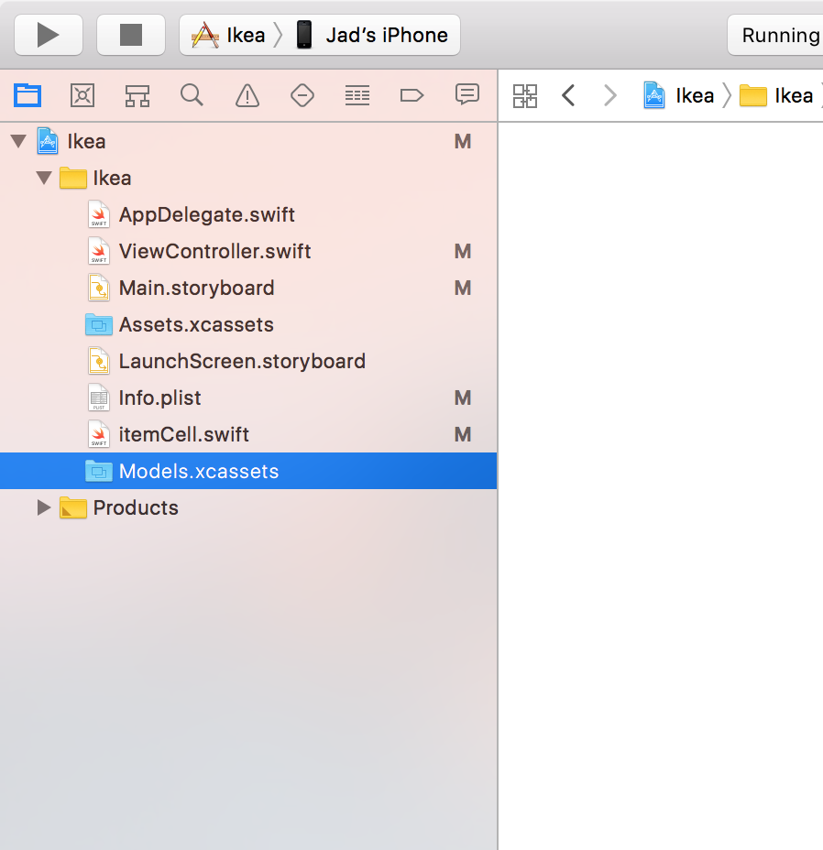

Make it into an scnassets, not xcassets

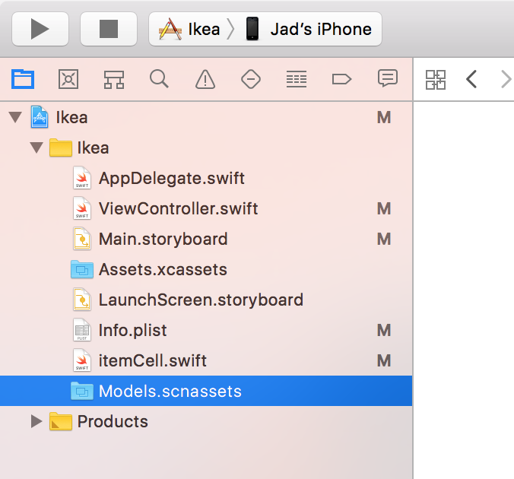

Download Assets.zip from Horizontal Hit-Testing (Resources).



Once downloaded,

Right click on your Models.scnassets,

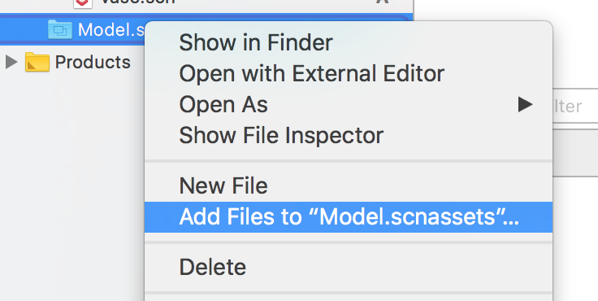

Add your models manually.

If for some reason, your models don't show up.

Close your Xcode project,

Open it Again.

You'll notice that nothing happened. However now, you should be able to add/drag them.

